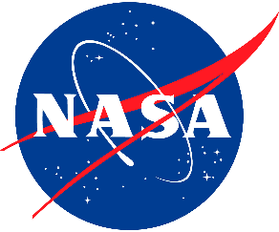 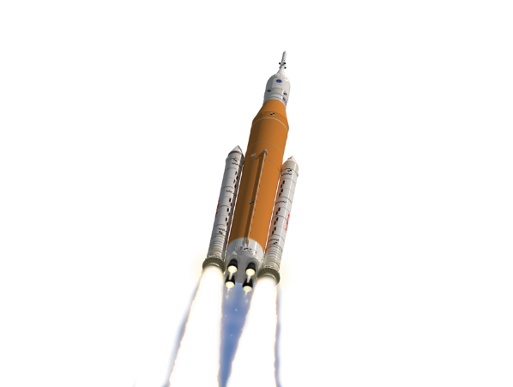

If not utilizing the links above, provide Submission to: [**hq-ncss@mail.nasa.gov**](mailto:hq-ncss@mail.nasa.gov)

* Subject Line: **2025 NCSS Award Nomination**

The selection process and criteria for the awards, along with the requirements and format for each award submission will soon be made available on the webite. Please follow the instructions for nomination.

Questions: Please email Ms. Kristen Kehrer,[**hq-ncss@mail.nasa.gov**](mailto:hq-ncss@mail.nasa.gov)

We are pleased to announce the **Call for Awards** for our upcoming 2025 NASA Cost and Schedule Symposium (NCSS).

There has been a great deal of hard work completed by both outstanding individual performers and estimating teams throughout our Agency in the past year!  We all know the importance of recognizing people who have done outstanding work.  It is now time for each of us to nominate our colleagues that have distinguished themselves through their accomplishments, dedication, leadership, and teamwork over this past year.  Please do not miss this opportunity to write up and submit award nominations for those you feel are deserving of recognition.

We are accepting nominations for the awards below. Click on the link to prepare and submit your nomination. If you are unable to utilize this link, go to the NCSS website to find links for both web-based and Microsoft Word submission forms.

* [2025 Cost and Schedule Leadership Award](https://forms.office.com/Pages/ResponsePage.aspx?id=WNQFcL5FrkiBQNQ9qW3Re6PhHcDXg81HoedaiGl0TJNUNVQ1VldPU1cxRlc0SEZGTEhYM1g0QjlVMi4u)
* [2025 Cost and Schedule Analyst of the Year](https://forms.office.com/Pages/ResponsePage.aspx?id=WNQFcL5FrkiBQNQ9qW3Re6PhHcDXg81HoedaiGl0TJNUMUI5MFc1Wkw5Vk9ZSDBXV1lBQjdIMU1FWS4u)
* [2025 Cost and Schedule Rising Star Award](https://forms.office.com/Pages/ResponsePage.aspx?id=WNQFcL5FrkiBQNQ9qW3Re6PhHcDXg81HoedaiGl0TJNUOVRNWTlMOURYNkU1UUFWQUI3UzQ4T0RHOC4u)
* [2025 Cost and Schedule Team Award](https://forms.office.com/Pages/ResponsePage.aspx?id=WNQFcL5FrkiBQNQ9qW3Re6PhHcDXg81HoedaiGl0TJNUMzVRUEsyVU41SkxCUFdVMkMzUVNIRFAxVi4u)
* [2025 Cost and Schedule Support Contractor of the Year](https://forms.office.com/Pages/ResponsePage.aspx?id=WNQFcL5FrkiBQNQ9qW3Re6PhHcDXg81HoedaiGl0TJNUQkVCSlZXTk00WFkwODFWNjNGUVpXQzE2US4u)
* [2025 Cost and Schedule Top Community Support Award](https://forms.office.com/Pages/ResponsePage.aspx?id=WNQFcL5FrkiBQNQ9qW3Re6PhHcDXg81HoedaiGl0TJNUOVZIOEdOSzIwSFZDQ0ZPWkJTS09XSTJBVy4u)
* [2025 William S. Rutledge Lifetime Achievement Award](https://forms.office.com/Pages/ResponsePage.aspx?id=WNQFcL5FrkiBQNQ9qW3Re6PhHcDXg81HoedaiGl0TJNUREZURjdaU0VXRUZWVU1UMFNERktYQlZXSi4u)

The descriptions for each award are available on the NCSS website: <https://www.nasa.gov/ocfo/ppc-corner/nasa-cost-and-schedule-symposium/>.

The awards will cover the period of April 30, 2024 – April 30, 2025. Nominations can be submitted by anyone in our NASA estimating and analysis community, but they must be emailed by close of business on March 14th, 2025.

**The NASA Cost, Schedule, and EVM**

**Communities invite you**

**to nominate your favorite Analyst!**

**Schedule and Due Dates**

March 14th: Award Nomination Deadline

April 30th: Awards Banquet at the U.S. Space and Rocket Center

**Award Descriptions & Nomination Submission Requirements** are posted on the NCSS website.

**Winners** will be announced at the Awards Banquet.

**Nominations and Winners** will be posted on the NCSS website after the Symposium.

**Symposium Logisitcs**

**April 29th – May 1st**

**Huntsville, Alabama**

**Registration Links and Detailed Logistics** are forthcoming and will be posted on the NCSS website.

**Contact Information**

Symposium Email:

[hq-ncss@mail.nasa.gov](mailto:hq-ncss@mail.nasa.gov)

Awards POC: Ms. Kristen Kehrer

Please contact utilizing NCSS Email.

**Symposium Website**

[www.nasa.gov/ocfo/ppc-corner/nasa-cost-and-schedule-symposium/](http://www.nasa.gov/ocfo/ppc-corner/nasa-cost-and-schedule-symposium/)

**2025 NASA Cost and Schedule Symposium**

**Call for Award Nominations**