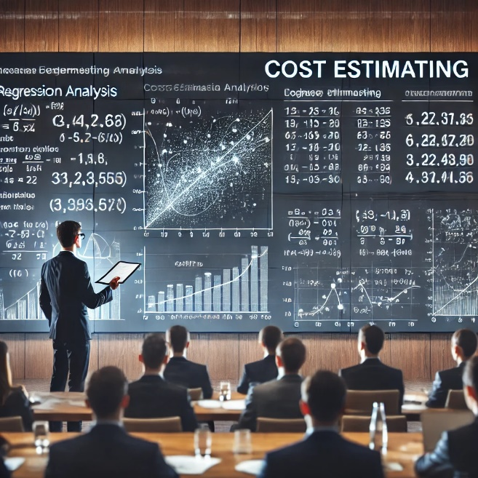

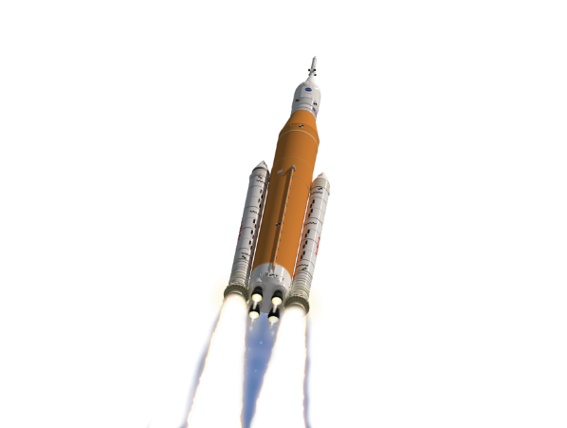

**Schedule & Due Dates**

February 14th: Abstracts Due

February 24th: Notification of Acceptance

April 21st: Presentations Due

**Final Symposium Agenda** will be posted on the NCSS website.

**Symposium Logisitcs**

**April 29th – May 1st**

**Huntsville, Alabama**

**Registration Links and Detailed Logistics** are forthcoming and will be posted on the NCSS website.

**Contact Information**

Symposium Email:

[hq-ncss@mail.nasa.gov](mailto:hq-ncss@mail.nasa.gov)

Abrstract POC: Mr. Charles Hunt

Please contact utilizing NCSS Email.

**Symposium Website**

[www.nasa.gov/ocfo/ppc-corner/nasa-cost-and-schedule-symposium/](http://www.nasa.gov/ocfo/ppc-corner/nasa-cost-and-schedule-symposium/)

**The NASA Cost, Schedule, and EVM**

**Communities invite you**

**to contribute to our annual**

**NASA Cost and Schedule Symposium!**

Provide Submission to: [**hq-ncss@mail.nasa.gov**](mailto:hq-ncss@mail.nasa.gov)

* Subject Line: **2025 NCSS Abstract**
* Please include:
  + A ***primary point of contact***
  + A list of***all authors***, including contact info
  + An *a****bstract*** not to exceed two pages
  + Desired ***time slot***\*: 30, 45, or 60 min

*Presentations should be 30 minutes, but please inform us in your email if you would prefer a 45 or 60 minute slot. There are a limited number of 45-60 minutes slots available.

Questions: Please email Mr. Charles Hunt, [**hq-ncss@mail.nasa.gov**](mailto:hq-ncss@mail.nasa.gov)

We are seeking presentations covering a wide variety of estimating and analysis topics, including:

* Cost and Schedule Risk Analysis
  + Techniques, Results, Lessons Learned
* Effects of Acquisition Approach on Estimating and Analysis
* Affordability and Sustainability Analysis
* NASA Policies on Cost, Schedule, and EVM
* Results of NASA Data Collection and Research
* Independent Cost and Schedule Assessment
* Cost and Schedule Analysis Tools, Methods, and Processes
* Schedule Management
* Earned Value Management
* Joint Cost and Schedule Risk Analysis

**2025 NASA Cost and Schedule Symposium**

**Call for Presentations**