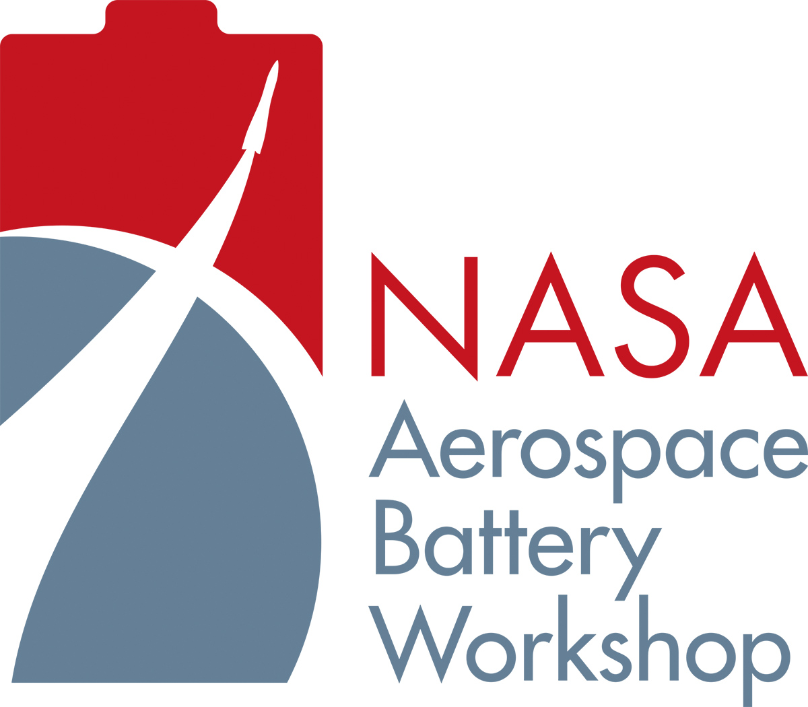
2024

November 19-21, 2024

Holiday Inn – Research Park
5903 University Dr. NW, Huntsville AL

AGENDA

Tuesday, November 19, 2024

7:30 – 8:30 Registration

8:30 Introductory and Welcome Remarks
Jeff Brewer: NASA

8:35 Modeling, Simulation and Physical Validation of Passive Battery Thermal Management Systems for Extreme Temperatures in Space Applications
Dr. David Noye: Nano Research Inc. Dr. Carol O Putman, NASA

9:05 Predicting Rapid Degradation Onset in Lithium-Ion Batteries during Real-Time Operation Using Machine Learning
Jaya Vikeswara Rao Vajja: Purdue University, Meghana Sudarshan, Brian Chuanyu Chang, Vikas Tomar

9:35 Analyzing Battery Performance in Electric Aircraft with Coupled Modeling of Flight Dynamics, Battery Physics, and Temperature
Lukas Kiesewetter: University of Alabama, Krishna Shah

10:05 – 10:20 Break

10:20 Addressing Challenging Thermal Runaway Simulation Requirements through detailed 3D CFD Models
Kislaya Srivastava, Tristan Burton : Convergent Science Inc.; Alexander Fandakov, Lorenz von Roemer, Marc Sens, Marcus Woebke : IAV GmbH

10:50 A Novel Way to Design and Parameterize Battery Packs
Javier Gazzarri: MathWorks

11:20 Systematic Model Reduction for Battery Health Monitoring: A Physics-Based Approach Applied to X-57 Battery Packs
Michael Khasin: NASA, Mohit Mehta, Katelyn Jarvis Griffith, John Lawson

11:50 – 1:30 Lunch

1:30 Deconfounding Cell Failure Effects and improving Outcomes: Early Monitoring, Detection, and Countermeasures
Brian Engle: Amphenol

2:00 Effect of Thermal Inertia On Accelerating Rate Calorimeter Results
Surendra Singh: Belmont Scientific

2:30 Correlating Cell Failing Delta OCV Testing with Cell Defects
Ruth Young, NASA-JSC

3:00 – 3:15 Break

3:15 Lyten’s Advanced Lithium-Sulfur Cells for Aerospace and DoD Applications
Yongtao Meng: Lyten, Ratnakumar Bugga, Zach Favors, Arjun Mendiratta, Babu Ganuguli, Jeffrey Bell, Karel Vanheusden and Celina Mikolajczak

3:45 Material Engineering of Anodes for Aqueous Batteries with Enhanced Performance and Stability under Aerospace Environmental Conditions
Nian Liu: Georgia Institute of Technology

4:15 ThermoArc: A new method of trigger thermal runaway in Li-ion like an ISCD but with a fraction of the cost
Thuong Nguyen: NASA, David Delafuente

4:45 Battery quality control via high-throughput CT scanning
Peter Attia: Glimpse

Special Workshop / Tutorial – Requires separate registration from Battery Workshop
When: November 19th ~ 30 minutes after the final presentation
Title: China Battery Industry Technology Innovation Trends 2024
Speaker: Shmuel De-Leon, Shmuel De-Leon Energy, Ltd.
Separate registration is required at this link: China Battery Industry Technology Innovation Trends 2024

Wednesday, November 20, 2024

8:30 China Battery Industry – Rechargeable Cells Technology Innovations Trends 2024
Shmuel De-Leon: Shmuel De-Leon Energy, Ltd

9:00 Cracking the graphite-free Silicon Battery Code for market-leading Performance
Karthik Ramaswami: Sionic Energy, Derek Weber

9:30 Anode free Na batteries for Next - Generation Aerospace Applications
Reena Pachal: Rensselaer Polytechnic Institute, Joy Datta, Vrushali Varude, Kevin Bhimani, Varad Mahajani, Mithil Kamble, Apurva Anjan, Rohit M. Manoj, Helen Zha, Dibakar Datta, and Nikhil Koratkar

10:00 – 10:15 Break

10:15 20 years mission return experience on W3A first GEO satcom satellite ever launched with Li-Ion batteries.
Yannick Borthomeiu: SAFT, Max Montagne

10:45 UL 9540A Safety Standard Testing Requirements for Lithium-ion Batteries
Surendra Singh: Belmont Scientific, Derek Lovejoy

11:15 Enhanced COTS Cell Qualification with Electrochemical Pulsing Protocols
Blake Hawley: Voltaiq, Kevin N. Wood, Joseph R. Gallegos, Gregory B. Less

11:45 – 1:30 Lunch

1:30 Updated cylindrical pack design using non-metallic cell capture for JSC-20793 compliance
Richard Coffin: EaglePicher Technologies

2:00 Streamlining Energy Storage Solutions for CubeSats and Small Sats: Pre-Certified 20793 Compliant Battery Systems for NASA’s Artemis Missions
William Walker: KULR

2:30 Fast Charging Protocols Considering Safety based on Electrochemical-Thermal-Life model for Lithium-Ion Batteries
Kyungjin Yu, Adekanmi Miracle Adeyinka, Song-Yul Choe (Auburn University), Wooju Lee (Hyundai Motor Company)
3:00 – 3:15 Break

3:15 Optimizing Gravimetric Energy Density in PPR Battery Packs by Integrating Spine Heat Sinks with 21700 Cells
David Petrushenko: NASA, Jesus E. Trillo, Eric C. Darcy, Paul T. Coman, Ralph E. White, Zoran M. Bilc

3:45 Correlative Microscopy and AI-assisted Image Analysis Synergetic Approach on NMC Cathodes
Hughes “H” Francois-Saint-Cyr: Thermo Fisher Scientific, Chengge Jiao, Chris Stevens, Rengarajan Pelapur, Luigi Raspolini

4:15 Sidewall Rupture Characterization of 21700 Lithium-Ion Cells
Jesus Trillo: NASA, Eric C. Darcy, David Petrushenko, Zoran M. Bilc

4:45 Precursor Reaction Pathway Leading to BiFeO3 Formation: Insights from Text-Mining and Chemical Reaction Network Analyses
Viktoriia Baibakova: Lawrence Berkeley National Laboratory, Kevin Cruse, Michael Taylor, Carolin M. Sutter-Fella, Gerbrand Ceder , Anubhav Jain , and Samuel Blau

Special Workshop / Tutorial – Requires separate registration from Battery Workshop
When: November 20th ~ 30 minutes after the final presentation
Title: Battery Safety – Reducing Battery Safety Risks
Speaker: Shmuel De-Leon, Shmuel De-Leon Energy, Ltd.
Separate registration is required at this link: Battery Safety - Reducing Battery Safety Risks

Thursday, November 21

8:30 Liquefied Gas Electrolyte for Next-Generation Li-Ion Batteries
Charlie Krause: South 8 Technologies

9:00 Build Long-Term Stable High-Energy Lithium Metal Batteries
Xiangbo (Henry) Meng: University of Arkansas

9:30 Development Analysis and Test Results for The Newly Designed Large-Capacity Li-Ion Battery
Ittetsu Ohira: Mitsubishi Electric Corporation, Kentaro Marutani, Takeshi Kiyokawa, Shintaro Hamada, and Seiichi Handa: Japan Aerospace Exploration Agency (JAXA) Hitoshi Naito, Makoto Kawase

10:00 Design Driving Factors for Allowing Metallized Plastic Current Collectors to Isolate Internal Short Circuit in High Energy Li-ion Cells
Eric Darcy: NASA-JSC

10:30 De-orbit and re-fuel missions using Li-CFx battery technology
Greg Miller: EaglePicher Technologies

11:00 Sodium-Ion Batteries in Aerospace Applications
Frank Oliver: Airtronics

12:00 Closing Statements, Conference Conclusion

